



202401100400053

ROLL **N0-4** SUBJECT --Al MSE2

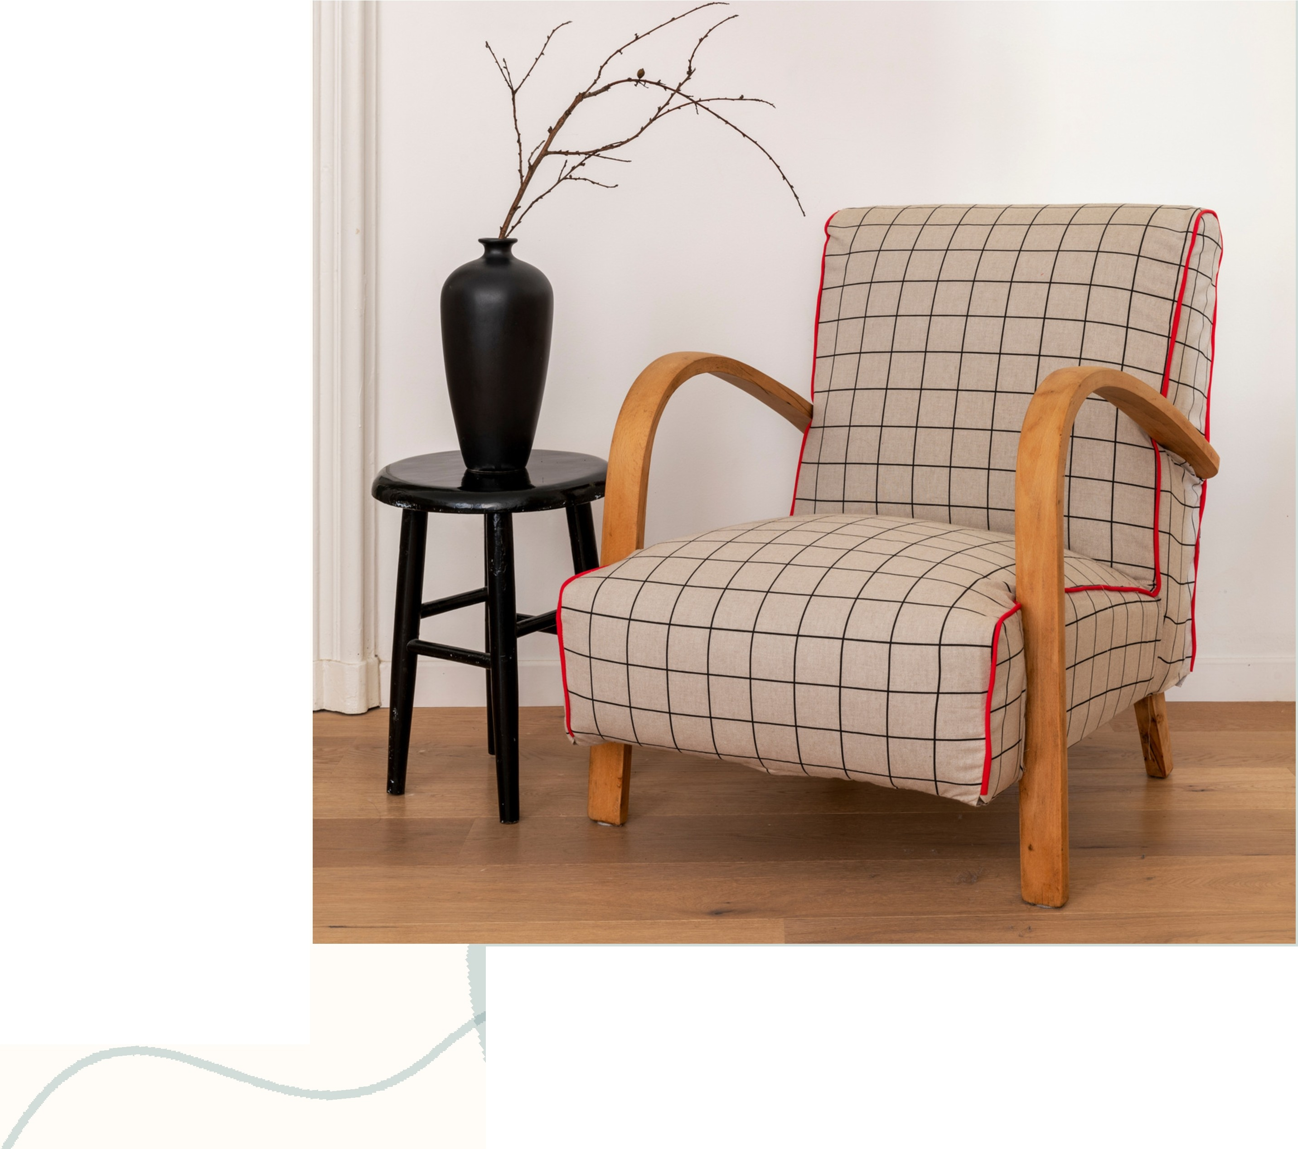I. Introduction

Sudoku is a logic-based number placement puzzle where the objective is to fill a 9x9 grid so that each row, each column, and each 3x3 subgrid contains all digits from 1 to 9 without repetition.

Solving Sudoku puzzles manually can be time­ consuming, and thus, an automated solver using Python can significantly enhance efficiency.

This report presents a Python-based Sudoku solver that employs the backtracking algorithm to solve puzzles efficiently.

c. Methodology



# Methodology

Approach Used: 

1. Input Handling: The Sudoku puzzle is represented as a 9x9 matrix, with empty cells denoted by 0.
2. Backtracking Algorithm:

o Find an empty cell.

0 Try placing numbers 1 to 9 sequentially.

° Check if placing a number violates Sudoku constraints.

0 If a valid number is found, proceed to the next empty cell.

0 If no valid number is found, backtrack to the previous step and try a different number.

1. Output Display: The completed Sudoku grid is displayed once a solution is found.

# REFERENCE

* Python official documentation: https://docs.python.org/3/
* Backtracking algorithm concepts from

various online resources.

* Sample Sudoku puzzle sourced from open datasets.

GitHub Repository

Ensure that the following files are uploaded to the GitHub repository:

* Sudoku_Solver.ipynb (Jupyter Notebook containing the code)
* Report.pdf (This report in PDF format)
* README.md (Instructions on how to use the Sudoku solver)

def is_valid(board, row, col, num):

# Check if the number is not already in the current row for i in range(9):

if board[row][i] == num:# If the number is found in the row, return False

return False



# Check if the number is not already in the current column

if board[i][col] == num:# If the number is found in the column, return False

return False

# Check if the number is not already in the 3x3 subgrid if board[3 *(row// 3) + i // **3][3** *(col// 3) + i % **3]** == num:

return False

return True# Return True if the number is valid for the cell

# Function to solve the Sudoku puzzle using backtracking def solve_sudoku(board):

# Iterate over each cell in the grid for row in range(9):

for col in range(9):

if board[row][col] == 0: # Check if the cell is empty

Example Sudoku puzzle with O representing empty cells sudoku_board = [

|  |  |  |  |
| --- | --- | --- | --- |
| [5, 3, | 0, 0, 7, 0, 0, 0, OJ,# | | Row 1 |
| [6, 0, | 0, 1, 9, 5, 0, 0, OJ,# | | Row 2 |
| [O, 9, | 8, 0, 0, 0, 0, 6, OJ,# | | Row 3 |
| [8, 0, | 0, 0, 6, 0, 0, 0, 3J,# | | Row 4 |
| [4, 0, | 0, 8, 0, 3, 0, 0, 1J,# | | Row 5 |
| [7, 0, | 0, 0, 2, 0, 0, 0, 6J,# | | Row 6 |
| [O, 6, 0, 0, 0, 0, 2, 8, OJ,# Row 7 | | | |
| [O, 0, 0, | | 4, 1, 9, 0, 0, 5J,# | Row 8 |
| [O, 0, 0, | | 0, 8, 0, 0, 7, 9J# | Row 9 |

J

# Solve the puzzle and print the result

if solve_sudoku(sudoku_board):# Check if a solution exists print(11Solved Sudoku board:11) # Print success message print_board(sudoku_board)# Display the solved board

else:

print(11No solution exists.11) # Print failure message if no solution is found

--

•

Before Solving:

[5, 3,

Board

Sudoku

[6, 0,

0, 0, *7,* 0, 0, 0, 0]

0, 1, *9,* 5, 0, 0, 0]

[0,

*9,* 8,

0, 0,

0, 0,

6, 0]

[8, 0, 0, 0, 6,

0, 0, 0, 3]

[4, 0, 0, 8, 0,

3, 0, 0, 1]

[7, 0, 0, 0,

2, 0, 0, 0, 6]

[0, 6,

[0, 0,

[0, 0,

0, 0,

0, 4,

0, 0,

0, 0,

1, *9,*

8, 0,

2, 8, 0]

0, 0, 5]

0, *7,* 9]

Sudoku Solving:

After

Board

[5, 3,

4, 6,

*7,* 8,

*9,* 1, 2]

[6, *7,* 2,

1, *9,*

5, 3,

4, 8]

[1, *9,* 8,

3, 4, *2,*

5, 6, 7]

[8,

5, *9, 7,* 6,

1, 4, 2, 3]

[4,

2, 6, 8,

5, 3, *7, 9,* 1]

[7,

1, 3, *9,*

2, 4, 8, 5, 6]

[9,

6, 1, 5,

3, *7,* 2, 8, 4]

[2, 8, *7,*

4, 1,

*9,* 6,

3, 5]

[3, 4, 5, 2, 8,

6, 1,

*7,* 9]

OUTPUT